Supplementary Material
(Revised Version for the v1.3 Printed Circuit Board), by MJY Zimmermann

Openspritzer: an open hardware pressure ejection system for reliably delivering picolitre volumes
Forman, C.J.1,4§, Tomes, H.2, Mbobo, B.2, Baden, T1,3,4§., Raimondo, J.V.2,4§

Affiliations:
1) School of Life Sciences, University of Sussex, United Kingdom
2) Division of Physiology, Department of Human Biology, Neuroscience Institute and Institute of Infectious Disease and Molecular Medicine, Faculty of Health Sciences, University of Cape Town, Cape Town, South Africa
3) Institute for Ophthalmic Research, University of Tuebingen, Germany
4) TReND in Africa gUG (www.TReNDinAfrica.org)

§Correspondence: C.F.: chrisforman@cantab.net, T.B.: t.baden@sussex.ac.uk, J.V.R.: joseph.raimondo@uct.ac.za

Command duration is correlated to dosage

Supplementary Figure S1: The integrated area for each puff plotted against the command duration. The area under the puff profile is proportional to the dosage. Command duration and dosage are strongly correlated, regardless of the details of the puff profile over time.
Overview

This document contains detailed assembly instructions and an operation manual for Openspritzer and also includes a parts list. The Arduino code and 3D printing files for the exterior casing are provided and may be downloaded at https://github.com/BadenLab/Openspritzer. The purpose of the device is to regulate the pressure and duration of a puff of compressed air. Typically, the output port is connected to a glass puffer pipette which has been drawn into a sharp point with a narrow (<2-3 μm) diameter pore.
The device consists of a circuit board, a solenoid valve, a pressure regulator with a gauge and various interface components. Supplementary Fig. S2 shows the device without the covering lid and the solenoid displaced to expose the circuit board. The pressure regulator is mounted on the right and attached to the front panel via a retaining threaded ring that comes with the regulator. The printed circuit board (PCB) is mounted onto attachment points on the bottom of the box. There is a platform supports on which the solenoid can rest above the circuit board and a LED can be attached to a mount-point on the lid.

Supplementary Figure S2: Openspritzer consists of a pressure regulator, a solenoid and a control circuit. Its purpose is to control the strength and duration of a puff of compressed air, which is connected to a glass pipette that typically contains reagents for microinjection into biological samples.

Parts List
Supplementary Table 1 has an exhaustive list of parts, suppliers and prices, allowing calculation of the total cost of parts, which is between £320 and £360 at submission, depending on how much of the full system one chooses to include. Much of the circuitry e.g. the Arduino, footswitch and toggle switch is purely for convenience. A core functional system consists of the regulator, solenoid and a much simpler control circuit under TTL pulse control. The simpler minimal circuit is indicated in the construction instructions below and consists of the branch of the circuit containing the transistor.
In addition, prices are highly variable depending on local availability of components. For example, the single most expensive component when we assembled ours was the regulator which cost £180 at the time. However, we subsequently found the same regulator for $43 in a different country. If one is prepared to shop around, we estimate that a functional Openspritzer without add-ons could be constructed for as little as £175. If one has all the components it takes approximately 1 hours to construct a full Openspritzer depending on experience and excluding the print time for the case and lid.
Frequently components only come in bags of 10 or 50 so if one only intends to fabricate a single device there may be an additional overhead of extra parts, depending on the flexibility of your supplier. For example, ours cost £360 for the parts actually included in the device, but we paid £495 in total and now have some spare components for additional units.
Name | Manufacturer | Order ID | Retailer | Quantity | Observation 1 |  | Observation 2
Solenoid (either 2 ms or 7 ms model) | FESTO | MHE2-M1SH-3/2G-M7-K-RR | Kiowa | 1 | Pneumatics |  | 2 ms response + cable
Precision pressure regulator | FESTO | LRP-1/4-4 | RS | 1 | Pneumatics |  | 0.05 to 4.0 bar
Gauge | FESTO | MAP-40-4-1/8-EN | Kiowa | 1 | Pneumatics |  | 0.0 to 4.0 bar, 1/8 inch thread
Push-in (6 mm) to thread (1/4") | FESTO | QSL-1/4-6 | RS | 1 | Pneumatics |  | 6 mm to 1/4 inch
Push-in (4 mm) to thread (1/4") | FESTO | QS-1/4-4 | RS | 1 | Pneumatics |  | 4 mm to 1/4 inch
Push-in (4 mm) to thread (M7) | FESTO | QSM-M7-4-I | RS | 2 | Pneumatics |  | 4 mm to M7 thread
4mm OD plastic tubing | FESTO | PUN-4x0.75 | RS | 12 cm | Pneumatics |  | 4 mm OD and 10 bar
PicoNozzle Kit | World Precision Instrument | 5430 - x | WPI | 1 | Pneumatics |  | for 1.0 / 1.2 / 1.5 / 2.0 mm glass pipettes
Arduino Nano | Arduino |  | RS | 1 | Electronics |  | nano
PCB socket | Samtec | SSW-116-02-G-S | RS | 2 | Electronics |  | 1 row, 15 pin
Darlington pair NPN transistor | Fairchild | KSP 13BU | Farnell | 1 | Electronics |  | Ic = 500 mA, Vces = 30 V
1 k? variable resistor | Vishay | 249FGJSPXB25102KA | RS | 1 | Electronics |  | panel mount
Knob for variable resistor | RS Online | 783-0192 | TE Connectivity | 1 | Electronics |  | 6.35mm shaft radius
DPDT switch | Multicomp | 2MD3T2B2M6RE | Farnell | 1 | Electronics |  | ON-(OFF)-ON panel mount
SPST footswitch | RS Online | 335-319 | RS | 1 | Electronics |  | push-to-contact
24V DC desktop PSU 2.1 mm jack | RS Online | 436-058 | RS | 1 | Electronics |  | 24 V dc 1 A
2.1 mm right angle DC socket | RS Online | 884-0957 | RS | 1 | Electronics |  | 2.1 mm right angle
24 V Zener Diode | Semiconductor | 1N5359BG | Farnell | 1 | Electronics |  | 24V
1N4148 signal diode | Fairchild | 1n4148 | Farnell | 1 | Electronics |  | 24V
1 k? resistor | Digikey | CF14JT1K00CT-ND | Digikey | 3 | Electronics |  | 1 k? through hole resistor
220 ? resistor | Digikey | CF14JT220RCT-ND | Digikey | 3 | Electronics |  | 220 ? through hole resistor
Voltage step-down regulator | RS Online | 533-3743 | RS | 1 | Electronics |  | 5V, 3A
Capacitor 680 µF | RS Online | 526-1569 | RS | 1 | Electronics |  | 24V minimum
Capacitor 220 µF | RS Online | 526-1480 | RS | 1 | Electronics |  | 24V minimum
Diode 1N5824 | RS Online | 714-6819 | RS | 1 | Electronics |  | 24V minimum
Inductor 33 µH | Bourns | RLB0914-330KL | Farnell | 1 | Electronics
3 mm LED | Digikey | 350-1557-ND | Digikey | 1 | Electronics |  | 3mm round, throughhole, grn
Mount for 3 mm LED | Digikey | 67-1330-ND | Digikey | 1 | Electronics |  | 3mm panel mount
BNC coaxial connectors | TE Connectivity | 1-1337542-0 | Farnell | 2 | Electronics |  | Right angle jacks, 50ohm
Cable Mount BNC Connector | RS Online | 546-3721 | RS | 1 | Electronics |  | Plug Crimp Termination
2 way JST Female Connector Housing | RS Online | 820-1611 | JST | 2 | Electronics
3 way JST Female Connector Housing | RS Online | 820-1614 | JST | 1 | Electronics
2 way JST PCB header | RS Online | 820-1554 | JST | 2 | Electronics
3 way JST PCB header | RS Online | 820-1557 | JST | 1 | Electronics
2 distinc colour wires | RS Online | 331-862 | RS | 20 cm | Electronics |  | 20 AWG
Cable shrink | RS Online | 170-6377 | RS | 5 cm | Electronics |  | Shrunk diameter 1.2 mm
Rocker LED switch |  |  | Ebay | 1 | Electronics |  | Round Switch / 3 pins
M3 x 10mm screw | RS Online | 660-4636 | RS | 4 | Mechanical |  | M3 x 10 Hex socket cap
M3 nut | RS Online | 122-4400 | RS | 4 | Mechanical |  | M3 nuts
M4 x 50mm Hex Socket Cap Screws | RS Online | 304-4592 | RS | 4 | Mechanical |  | M4 x 50
M4 nut | RS Online | 189-579 | RS | 4 | Mechanical |  | M4 nuts
Supplementary Table T1: Parts schedule for Openspritzer

Assembling the Stimulator
1 – Obtaining the custom-designed PCB
From the GitHub repository (https://github.com/BadenLab/Openspritzer/PCB), one can find the gerber.zip folder needed to order the PCB to any manufacturer company (i.e. https://jlcpcb.com). Ordering a minimum of 5 units should not cost more than £10. Gerber files were designed with KiCad 5.0. Schematics and PCB footprint can be downloaded and modified from the same repository if need be (Fig. S?).

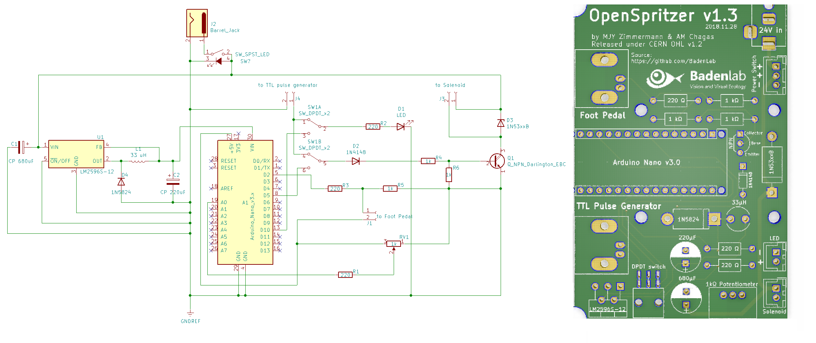
Figure Eschema and PCB

2 – Soldering the custom-designed PCB
The board is self-explanatory and should not take more than an hour to solder (Fig. S?)
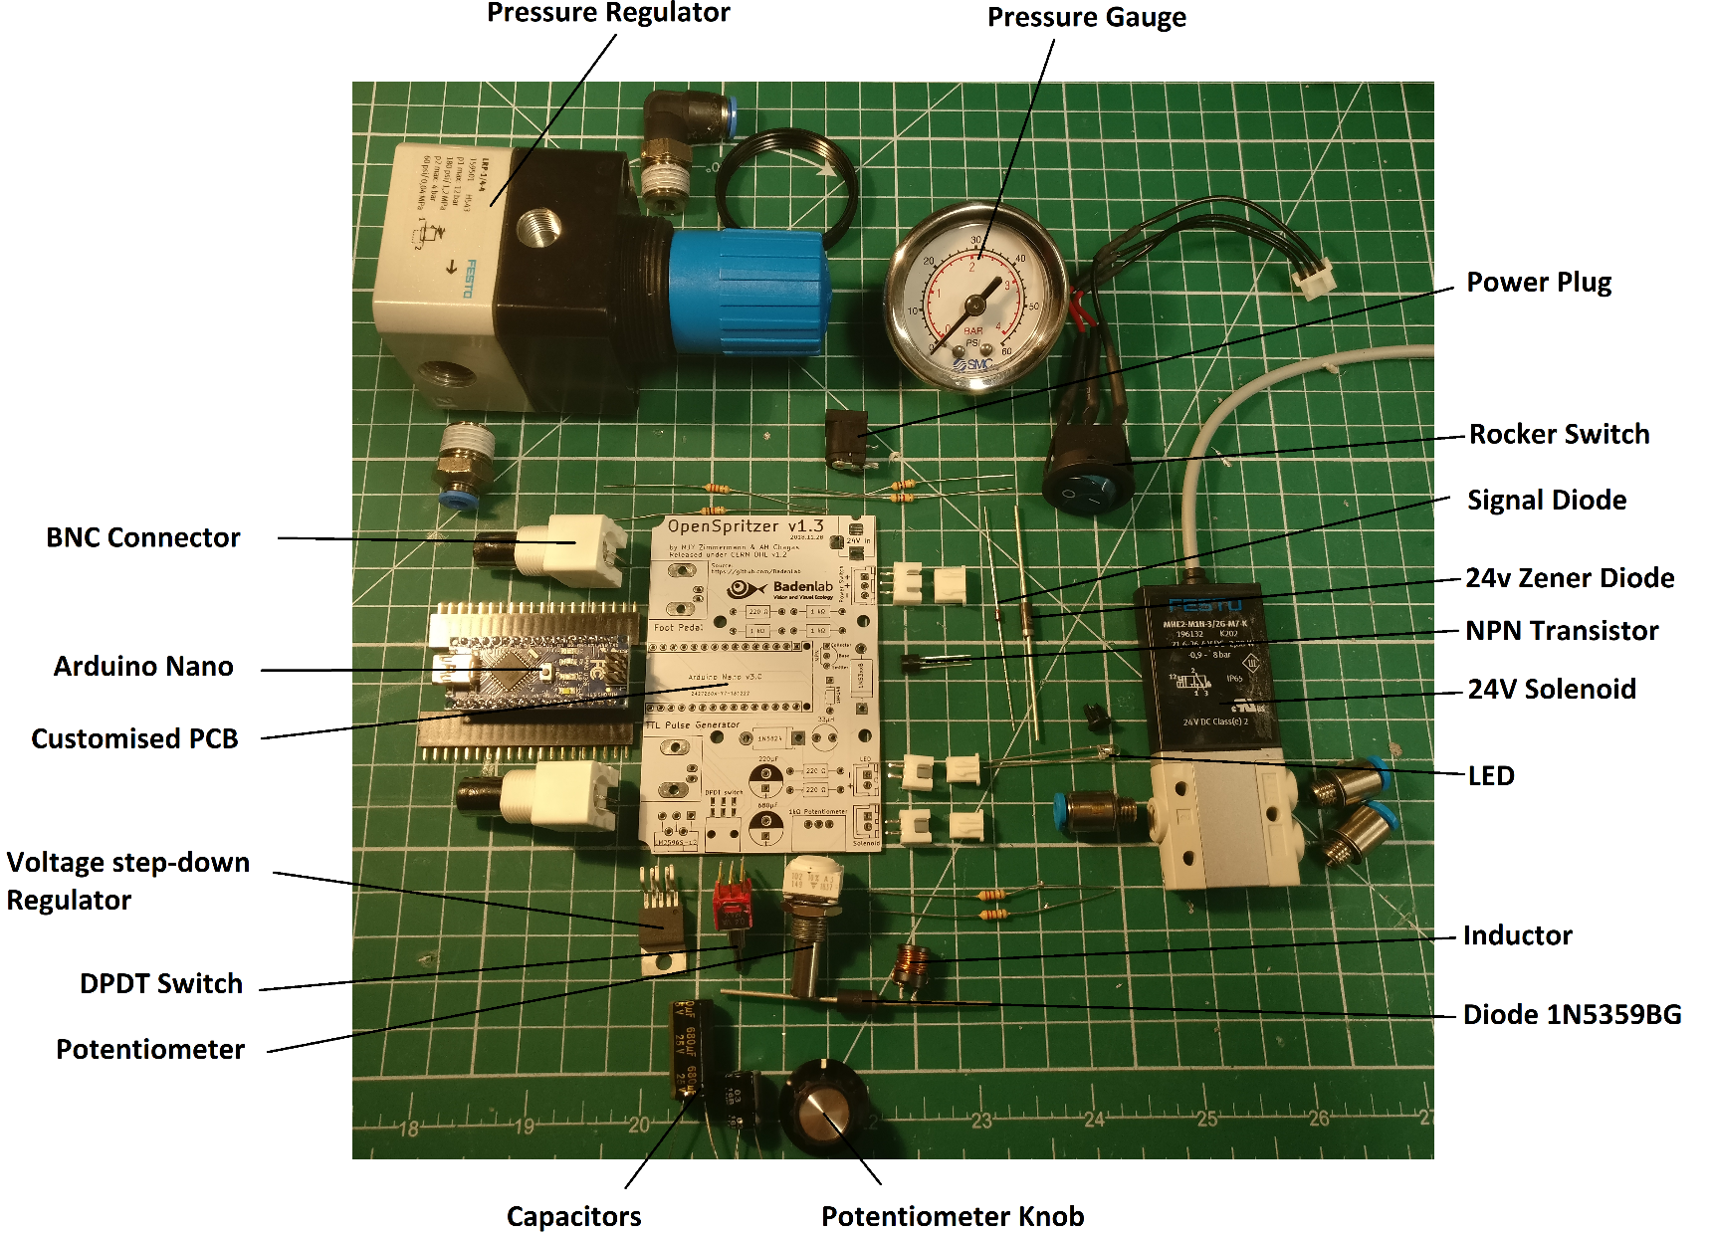

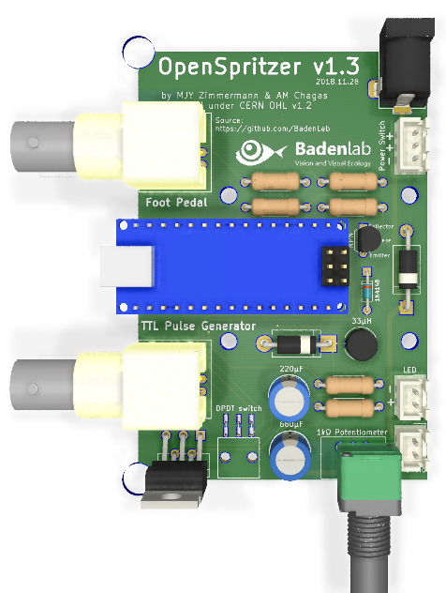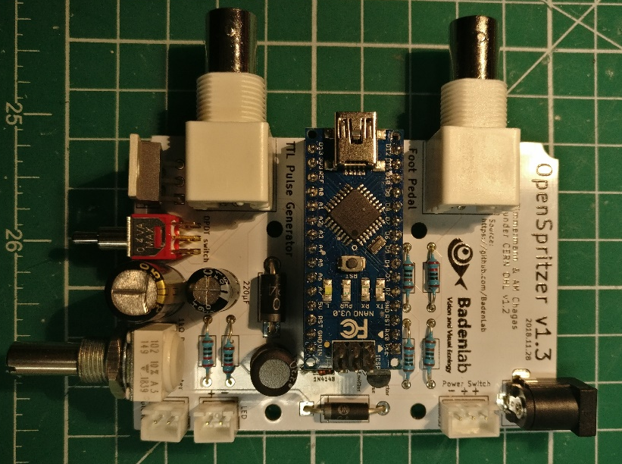

Supplementary Figure S?: Components and Assembly

3 – Printing the Stimulator box
STL files can be found on the GitHub repository and print directly. However, SCAD files are also available and easily adjustable for personalised design (Fig. S?).
We used OpenSCAD (freely available at www.openscad.com) to design the stimulator box. The tolerance of the printer can be adjusted in the “USER Parameters” section of the script (tol =0.1; by default, this value is used for Prusa MK3 and Ultimaker 2). Each component can be displayed/design individually in the “Switches” section. Variables can be adjusted in the “Component Parameters” section.
The PCB is screwed to the “Bottom” part of the box by using M3 screws and nuts.
All part should fit tightly together and are maintained together by 4 M3*50mm socket screws.

4 – Connecting the Stimulator
Connect an air compressor to the “Air In” port via the L-shaped adaptor.
The output airhose must be connected to the “Air Out” port.
A good pressure for sharp crisp pulses, which helps the solenoid to close again, is 1.4 bar (20 psi). Important: When first connecting high-pressure air to Openspritzer, e.g. from a compressor or air-tank, make sure that the Openspritzer gauge is near zero. A too-high line pressure (>>1.4 bar) risks irreversibly damaging the solenoid.
The stimulator must be powered with a 24v power supply. The Arduino Nano is powered through an internal voltage step-down regulator (24 to 5v). And does not need to be connected to be connected through a mini-USB cable once code has been uploaded.
For convenience in darkened circumstances the LED will also illuminate whenever the 5v line is high.
The foot pedal and/or the TTL cable(s), once soldered to a BNC male connector should be connected on the left side of the box to their appropriate BNC female connector. To operate with a footswitch the DPDT must be placed in Arduino mode and a 5 V power supply provided to the Arduino via the USB port. It is not necessary to use the Arduino to operate the solenoid if you have a convenient method for producing 5v TTL pulses, such as PulseQ electrophysiology package (Funetics) running on Igor Pro (Wavemetrics) in conjunction with the ITC 1600. To use TTL pulses ensure the DPDT switch is in the “TTL” position. Whenever the 5v line is high the solenoid will open and release compressed air from the output valve.
Using the Arduino to drive the puffer allows operation with the external footswitch. To operate with a footswitch the DPDT must be placed in “Foot Pedal”. Attaching a computer at operation time allows for dynamic reprogramming of the Arduino during experimentation, which could be very useful. E.g. resetting the base time unit.
To operate the unit, press the foot-button and after 400 milliseconds a puff of a predefined duration will occur. The LED will illuminate during the puff to give visual confirmation that the puff has occurred. The duration of the puff can be changed by adjusting the potentiometer.
When the potentiometer is changed Openspritzer goes into a monitoring mode during which time the LED is continuously lit. When the potentiometer stops changing, Openspritzer lits the LED to indicate the new time duration.
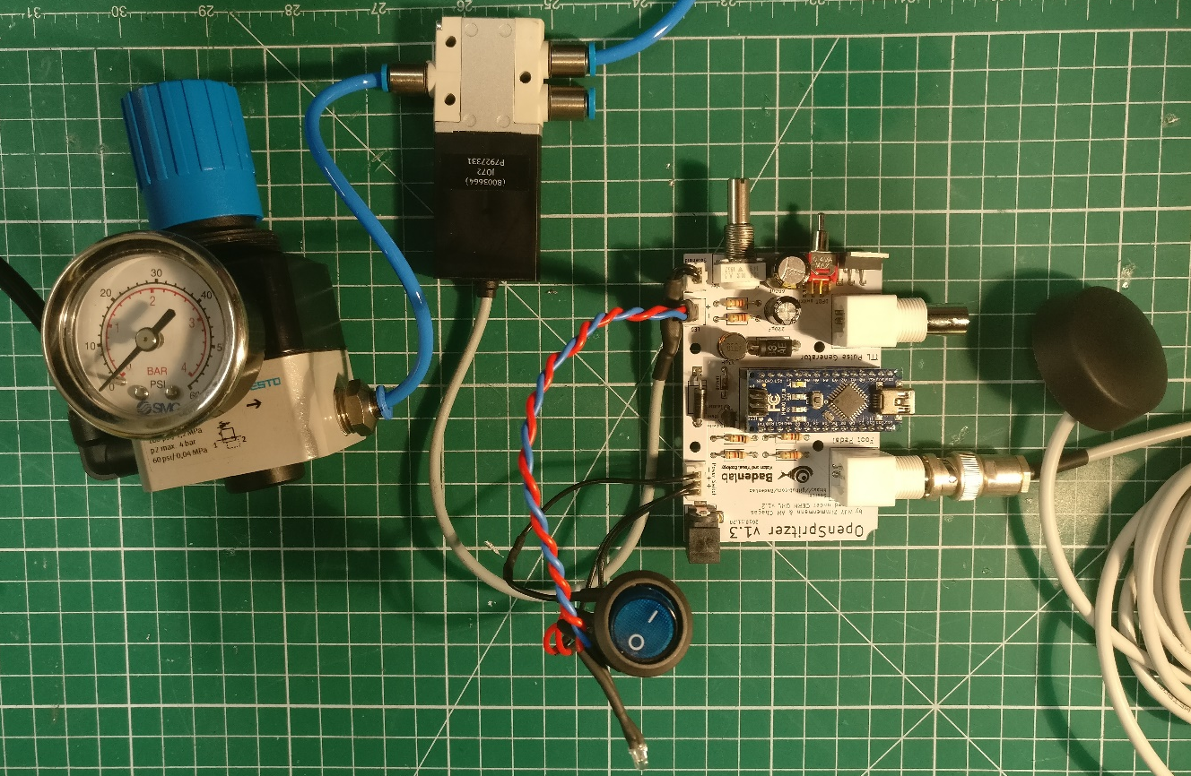

5 - Programming the Arduino on board Openspritzer
Once Openspritzer is assembled the Arduino must be programmed: Download and install Arduino programming environment on your computer (www.Arduino.org).
Open the Openspritzer.ino code which is included in the Supplementary Materials.
Compile and upload code to the Openspritzer by connecting the USB port of Openspritzer to the USB port of your computer and by clicking on the "Upload" icon in the top left corner of the screen.
Code can be modified and uploaded as many times as you like. The way the Openspritzer code has been constructed allows simple modification of key parameters such as the base unit of time and are listed in supporting table 2.
IMPORTANT: The first time that the Arduino is used the POT_LOW and POT_HIGH parameters should be measured. A Serial.println statement is included in the code to allow monitoring of this value over the serial port. To measure these values, open the serial port monitoring window in the Arduino programming environment (magnifying lens, top right corner) and then sweep the potentiometer from low to high. The two parameters POT_HIGH and POT_LOW should be initialised to the highest values and lowest values observed in the monitoring window output (usually those should be 0 and 1023). This is used in the calculations of the pulse duration and will vary from Openspritzer to Openspritzer depending on the precise value of the potentiometer resistance.
The monitoring algorithm relies on the PotNoise parameter to decide whether or not the potentiometer has settled. To set PotNoise, monitor the serial port output during the analog monitoring procedure (described above) and find the PotValue measured by the analogRead command. PotNoise should be larger than any fluctuations in the PotValue when it is not being altered. During testing, depending on which power supply was used, it was found that a reasonable value for PotNoise was 5.
Next the user assigns a time to the minimum and maximum potentiometer value by modifying PULSE_LOW and PULSE_HIGH. Those value are in milliseconds. PULSE_LOW will correspond to the minimum air puff duration when the potentiometer is turn all the way down, and reciprocally for PULSE_HIGH. By default those values are 10 and 1000 ms.
Finally, the PULSE_Delay is to be defined. This value allows some time for the user to release the button before applying the next pulse. This value can be adjusted to give rapid or spread pulses, however we found that for the average user, a value of 500ms is sufficient.
The user is obviously free to write any code they wish to monitor the foot button, read the potentiometer, blink the LED or operate the solenoid.

